2024 LOCAL DELIVERIES Analysis Report

Project Overview & Objective

The growing logistics provider, needed to move from static spreadsheets to an interactive, insightful dashboard to track their local delivery performance. The primary goals were to:

- Visualize Growth: Clearly demonstrate volume growth Month-over-Month (MoM) and progress from the start of the year through 2024.
- Analyze Operational Metrics: Accurately report on key metrics: Orders Delivered, Trucks Utilized, and Cases Shipped, on both a weekly and monthly basis.
- Identify Trends: Pinpoint peak seasons and weekly high-activity periods to aid in resource planning.
- Understand Client Base: Analyze the performance of Freight Forwarders (FFWs) and the breakdown of orders by required temperature (Ambient, Chill, Frozen).

Key Challenge & Data Transformation

The raw data presented a significant initial challenge that required advanced DAX and data modeling skills:
- The Problem: The source data listed each delivery order on a separate line. While correct for counting orders, it incorrectly duplicated the Truck ID for all orders delivered on the same truck on the same day. A simple count of distinct Truck ID values would have massively over-reported the number of trucks used.
- The Solution: I engineered a DAX calculation to create a "True Truck Count" metric. This measure calculates the number of unique trucks per day first, and then sums those daily counts across the selected time period. This ensured that the truck count was always less than or equal to the order count, reflecting the true operational reality.

The final deliverable was a two-page report providing insights at a glance and allowing for deep-dive analysis.

Page 1: Growth and Volume Overview
This page provides a high-level executive summary of yearly performance and key trends.

- MoM Growth Metrics: Key Performance Indicators showing the current month's totals and the Month-over-Month percentage change for Orders, Trucks, and Cases.
- Volume Handled MoM (Line Chart): A dual-axis line chart plotting the monthly trend of Orders and Trucks, clearly showing growth throughout the year and the efficiency ratio between orders delivered and vehicles used.
- Orders by Temperature (Pie Chart): A breakdown of total orders by temperature type (Ambient, Chill, Frozen), providing insight into the composition of the cargo handled.
- Top 5 Freight Forwarders (Bar Chart): Highlights the most frequent delivery destinations by order volume, helping identify strategic partners.
- Peak Season by Month & Week (Tables): Two table charts showing volume by Month and by Week Number. These visuals make it easy to identify historical peak seasons (e.g., a surge in Q4) and plan logistics capacity for the following year.

Page 2: Weekly and Monthly Deliveries
This page allows users to filter by a specific year and month to analyze granular, weekly performance.

- Time Filter Slicers: Interactive slicers for Year and Month enable users to focus on a specific period.
- Weekly Delivery Trends (Line Chart): Shows the volume of orders or trucks per week within the selected month, highlighting busy and quiet weeks.
- Detailed Data Table: A table presents the underlying numbers for the selected period, including columns for Date, Week Number, Orders, Trucks, and Cases. This supports the charts and provides exact figures for detailed analysis.

Business Impact & Value Delivered
This dashboard transformed the client's decision-making process:

- Data-Driven Decisions: Management can now make informed decisions on fleet allocation, staffing, and negotiations with Freight Forwarders based on accurate, visual data.
- Operational Efficiency: The accurate truck count reveals true resource utilization, identifying opportunities to maximize truck capacity and reduce costs.
- Performance Tracking: Leadership can track progress against annual goals in real-time, celebrating growth milestones shown by the MoM trends.
- Proactive Planning: Clear visibility into peak seasons allows the client to prepare for high-demand periods well in advance, ensuring they can meet customer expectations.

Growth & Volume:
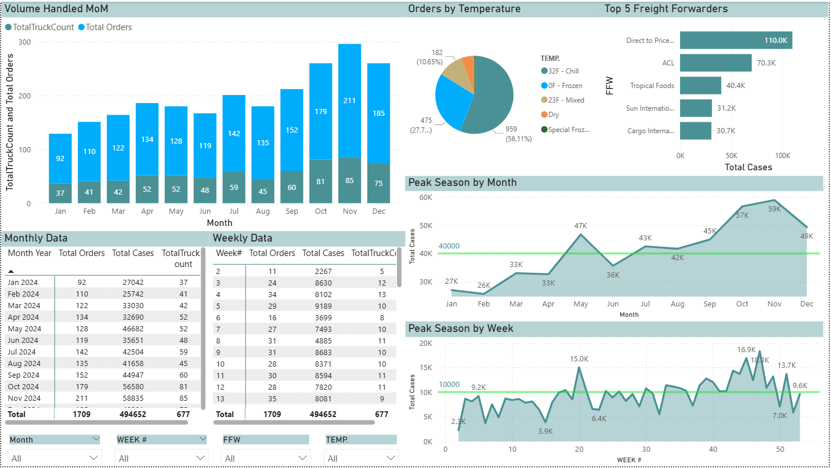

Weekly/Monthly Deliveries
